Setup QR Based Device Enrolment in Intune
Login to the client tenant
Open the Intune admin centre
Go to Devices > Android > Enrolment > Enrolment Profiles
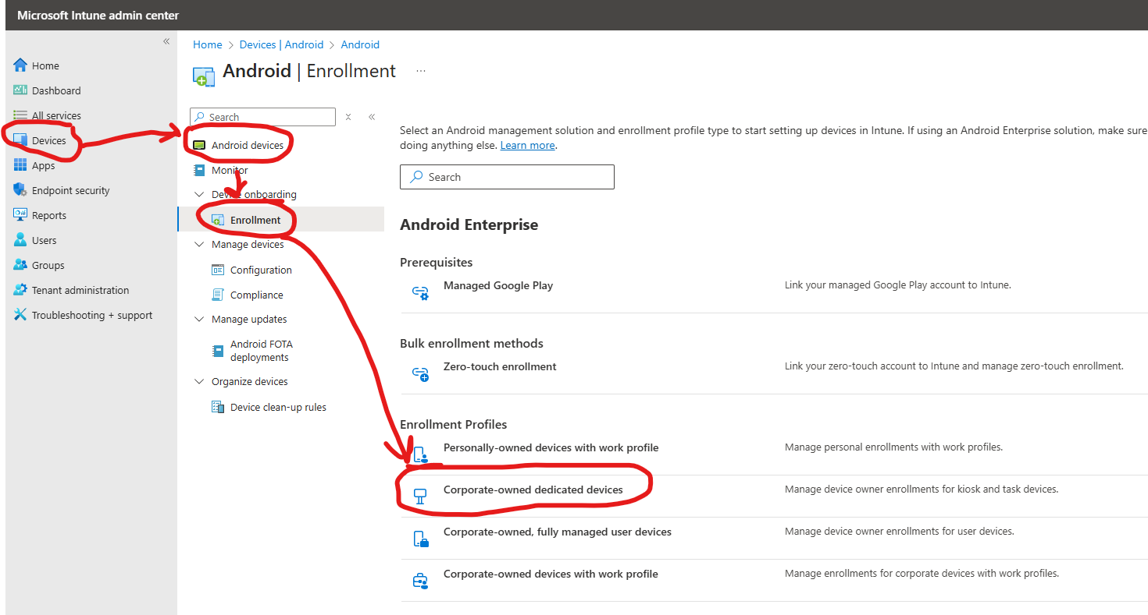
For almost all scenarios we will be using the corporate owned dedicated device profile
Create a policy, give it a sensible name, select the ‘corporate owned dedicated device (default)’ token type and set the expiration date. This is the date the QR code will stop working so you can control device enrolment in the wild (you can also revoke the QR code in the future)
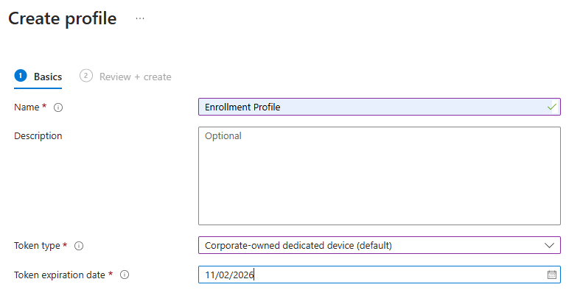
Click Next and Create and this will have created the enrolment token
Click on the Enrolment profile you have just created:
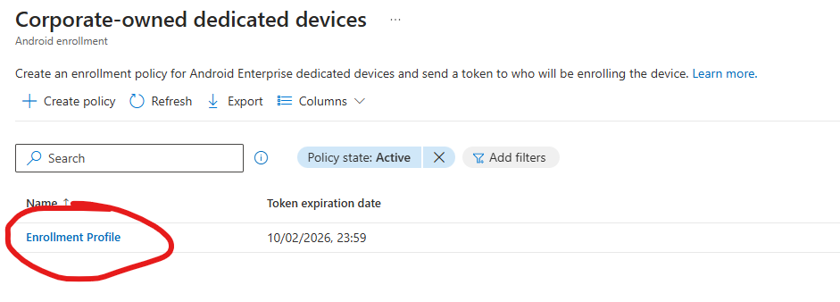
Then select ‘Token’ and ‘Show Token’ to get to the QR code
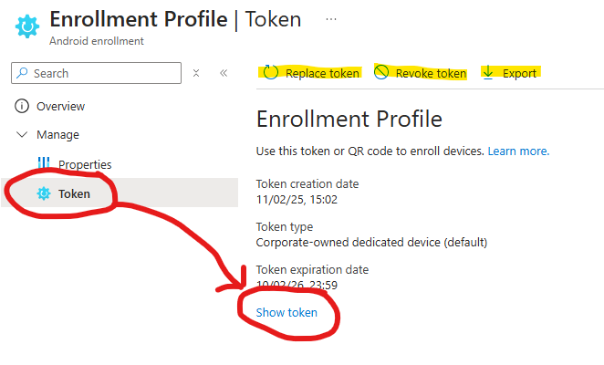
Please note the buttons for replacing the QR code or revoking it to prevent and further enrolment with it.
You can now save the image of the QR code, embed it in an email or webpage and enrol devices with it.

To enrol device with QR code
On a factory reset or new Android device, when at the welcome screen before you put any information into the phone tap the white space on the screen 6 times, this will bring up the QR scanner to enrol the device straight into Intune. This side steps a lot of the hassle of enrolling an android device.

